DRAFT

Connectionism, Incommensurability and the Knowledge Argument.

By

William Angelette

Lone Star College
Dec. 2012

Abstract

According to one version of the knowledge argument, provided with a future completion of science, admitting the possibility of counting a new color perception as contributing to a justified, true, belief commits one to rejection of the mind-body identity theory. Prior debate has been limited to traditional conceptions of knowledge. However, novel computer models of parallel distributed brain processes may offer fresh insight into the force of the knowledge argument.
I will demonstrate a series of ever more complex models that begin with two mutually constraining scientific values supposed to be functionally realized in human and animal brains. I will suggest a neural mechanism underlying rationality and recast the knowledge argument in terms of an updated version of Kuhn’s Incommensurability thesis.
Table of contents

Connectionism, Incommensurability and the Knowledge Argument. - 1 -
Introduction - 2 -
The Knowledge Argument - 2 -
Consensus from traditional debate: - 3 -
The Counting problem - 3 -
Scientific naturalism and the connectionist program - 5 -
The case for Connectionism - 6 -
Model virtues and limitations - 7 -
Incommensurability - 8 -
Mary’s exposure to Semantic Incommensurability - 9 -
Mary’s exposure to Methodological Incommensurability - 10 -
Merging three lines of thought - 11 -
The Knowledge Argument Redux - 12 -
Explanatory Breath and Simplicity. - 12 -
Theory, Meta-Theory and Background Belief - 14 -
Taxa, Language learning and Action (dthat) - 15 -
Emotion, Methodological Values and Action - 15 -
Harry’s Brain - 17 -
Conclusions further thoughts - 19 -

Introduction

The knowledge argument debate is usually framed within traditional conceptions of knowledge. However, novel computer models of parallel distributed brain processes may offer fresh insight into the force of the knowledge argument.
I will demonstrate a series of ever more complex models that begin with two mutually constraining scientific values supposed to be functionally realized in human and animal brains. I will suggest a neural mechanism underlying rationality and recast the knowledge argument in terms of an updated version of Kuhn’s Incommensurability thesis.
The plan of this essay is to bring together three lines of thought. (1) I’ll first present the case of “Mary”, Frank Jackson’s version of the knowledge argument, and briefly survey reactions to that argument. I will note and contest certain underlying assumptions about knowledge common among those reactions. (2) I will trace the role of these assumptions in the program of normative naturalism. (3) Using insights from psychology and connectionism, I will sketch a naturalist path towards unraveling the story of Mary.

The Knowledge Argument
Mary is a brilliant scientist who is, for whatever reason, forced to investigate the world from a black and white room via a black and white television monitor. She specializes in the neurophysiology of vision and acquires, let us suppose, all the physical information there is to obtain about what goes on when we see ripe tomatoes, or the sky, and use terms like ‘red’, ‘blue’, and so on. She discovers, for example, just which wavelength combinations from the sky stimulate the retina, and exactly how this produces via the central nervous system the contraction of the vocal chords and expulsion of air from the lungs that results in the uttering of the sentence ‘The sky is blue’. (It can hardly be denied that it is in principle possible to obtain all this physical information from black and white television, otherwise the Open University would of necessity need to use color television.)

What will happen when Mary is released from her black and white room or is given a color television monitor? Will she learn anything or not? It seems just obvious that she will learn something about the world and our visual experience of it. But then it is inescapable that her previous knowledge was incomplete. But she had all the physical information. Ergo there is more to have than that, and Physicalism is false (Jackson, F 1982).
This version of the knowledge argument may be read as asserting that, provided with a future completion of science, admitting even so much as the possibility of counting a new color perception as uniquely contributing to a justified, true, belief commits one to rejection of the mind-body identity theory.
Upon leaving the room Mary's new visual experiences, it seems, enter into the justification of further true assertions which she will confidently believe. But, it is not enough that Mary’s colorful experience should give rise to some assertions about color. The post color assertions must constitute learning. She may assert for example, “This red really exists.” This proposition could have been part of Mary's prior beliefs. While in the room she may have even imagined the day to come when she would see her hypothetical red color or marked the spot on a prism & chart where red would one day appear. But, while in the room, all this would not have risen to the level of knowledge unless her assertion could otherwise be justified sans perception on the basis of her physicalist knowledge base. Jackson’s argument denies that possibility. If the post color assertions are to be representative of learning, the colorful experience needs to be somehow responsible for that new learning. Thus, Jackson’s argument suggests that belief in all the true propositions derivable from a completed physical theory together with all imaginable experience still fails to justify the assertion (or denial of) “This red really exists.”

Consensus from traditional debate:

Since its introduction in the late twentieth century this version of the knowledge argument has inspired a flood of debate and the consensus is that the argument fails. Even Jackson himself changes his mind (cf. Jackson 2003). In general, three types of argument have been offered against Jackson’s original conclusion. Few deny the validity of the argument or at least some revised version. Rather, most challenge the soundness of the argument by denying that Mary will gain some new knowledge upon her release. It is useful to sort the critical replies according to the several dominant semantic theories of the time.
The ‘ability reply’ for example suggests that on leaving the black-and-white room, Mary gains an ability without learning a new fact (Nemirow 2004 and Lewis 1983). Fregeian semantics offers that Mary learns a fact she already knew under a new mode of presentation (Loar 1990) while Russellians might think that Mary gains acquaintance with a property without learning new facts (Conee 1985). More recently Dan Dennett puts it down to Jackson’s failure of imagination and asserts that Mary does know about color experience even from inside her room (Dennett 2006 2011).

The Counting problem

Suppose we accept it that Mary's new perceptions, enter into the justification of further true assertions which she will confidently believe. The underlying assumption explicit or implied in the knowledge argument becomes: A class of meaningful sentences, true, assertions, reflects the body of justified beliefs that compose the sum of knowledge. This way of looking at things gives rise to the counting problem because competing semantic theories disagree on how to arrive at and recognize a unit of meaning. Jackson’s (and critical) argument relies upon us supposing that there is an easy way to count knowledge.
Now, if I’m counting jelly beans and put all the cherry ones in one cup and all the lime ones in another, no one is likely to be puzzled if I claim to have more lime than cherry jelly beans. But, this is a naive picture of counting. Things are much more problematic if we want to quantify knowledge. On the naïve view, it looks like knowledge counting follows the same simplistic procedure as bean counting. In one column we stack the ‘bits’ of physical knowledge. In the other column we need to stack some other ‘bit’ and label the column, ‘other knowledge’. As long as it looks like there is a possibility to fill the second column with something it won’t matter how we did the individuation and counting. It seems, it will make sense to talk of more knowledge. Our next step, on this picture, might be to ask if the ‘bit’ we’re considering for the second column is a justified, true, belief (+) or is in some other sense knowledge. Throughout, and especially at this last step, each critic will consult her theory of meaning to decide whether or not there is something significant there to point to.
As we've noted earlier, however, competing theories of meaning result in disagreement on the unit of meaning and methods for analysis. Some even suggest that meanings ought to be abandoned. It is clear that conclusions about the possibility of new knowledge depend upon principles of counting and individuation allowed by a semantic theory. With this in mind criticism of the knowledge argument begins to look more like a magic trick instead of reasoned analysis. If you come to the table with a competing semantic theory, how can one get a fair count once the magician clicks his semantic-theory-wand against the cup of new knowledge?
This is particularly embarrassing for arbiters of the knowledge argument since we seem to have no higher authority, no meta-language from within which to referee the debate. Among the knowledge argument critics, no one much minds this state of affairs so as long as everyone comes to the same general conclusion. But, much of that debate can be considered a red herring once we realize that this whole project of counting is misguided.
It was the wrong picture. Knowledge, so conceived, is a convenient fiction. There is a glaring mismatch between that picture of knowledge and what we know about how brains work. Knowledge does not lay waiting in a stack of possible assertions.
Suppose, as is supported by empirical evidence from neuro-psychology, that knowledge is a matter of continual processes of attention, and interaction with the environment, involving both retrieval, and construction. This alternative picture now developing in neuro-psychology may better square with findings offered by connectionist cognitive science.

Scientific naturalism and the connectionist program

Our course of investigation is extremely complex. It will be necessary to give but brief sketches of the many tiles that must all fit together before the full mosaic of the research program can be pieced together. Much of that mosaic relies upon Connectionism and its relationship to Scientific Naturalism. Connectionism is a cross disciplinary research program that combines most conspicuously considerations of philosophy, psychology and computer science. Indeed, elements of anthropology, linguistics and even physics also fall within its purview. Broadly speaking it is a type of scientific naturalism that investigates the nature of consciousness in a particularly distinctive way. In order to remove an unnecessary stumbling block, let us first look at the sort of naturalized philosophical approach that I have in mind and then move on the case for connectionism.
We are interested in looking at a brand of naturalized philosophy that allows us to use some accepted methods of science, particularly the method of mathematical modeling, to sketch out specifics of Jackson’s imagined scenario. We’d like that model to cohere with the largest body of information available to us from neuro-science.
Our goal is to find an alternative approach to the knowledge argument that does not fall prey to the counting problem and is sensitive to insights from neuro-psychology. As we will see a connectionist program supported by a scientific naturalist methodology provides such an alternative.
But doesn’t proceeding on the basis of a naturalist methodology wrongly commit us to the very position that is at issue, namely Physicalism? First let’s note that not every brand of naturalist philosophy commits one to rejecting the knowledge argument. I will restrain myself to a methodological naturalism. Methodological naturalized philosophy is just a defeasible recommended procedure of analysis. I will proceed as if the current methods of science offer the possibility of causal insight -- innocent enough. We can begin the investigation by offering it as a mere hypothetical alternative. At the end of the day we can argue abductively in terms of argument to the best explanation.

The case for Connectionism

Twentieth century epistemology and science fiction familiarized us with the idea that intelligence, perhaps even a mind, might one day be realized via some alternative to the human body. Most often this involved thinking of minds like computers, or in the opposite direction, thinking of computers like minds. For some this went beyond mere analogy and the possibility was taken quite literally.
The program of artificial intelligence AI took as its prototype the Van Neumann architecture. According to the Van Neumann model we require a storage unit analogous to long term memory, a buffer memory for working memory, and a central processor to perform mathematical functions on whatever is streamed through it. We are all now quite familiar with this picture through our experience with the ubiquitous personal computer which still follows this model. This picture of mind is almost entirely at odds with contemporary neuro-science. Connectionists contend that distributed processing is a much better fit with neuro-science.
Connectionism is distinguished from good old fashioned AI most clearly by its abandonment of the Van Neumann model. Connectionism takes its inspiration from the structure of (simple electro-chemical communication among groupings of) neurons. Connectionism requires no one executive or central processor. Nor do the individual nodes of a connectionist network require the ability to perform complex programs passed from stored memory banks. There are no memory banks. In a certain sense there is no storage of knowledge at all. ‘Knowledge’ if we may call it that, arises from the system as a consequence of relationships between prior and future demand. Just as in our own brains, the information is distributed and superimposed.
Distributed representations for complex expressions like ‘I see a ripe red tomato.’ can be constructed that do not contain any explicit representation of their parts (Rumelhart, D.E., J.L. McClelland 1986, Smolensky 1991). The information about the constituents can be extracted from the representations, but neural network models do not need to explicitly extract this information themselves in order to process it correctly (Chalmers 1990). From these features of connectionist networks it becomes plausible that we may escape the counting problem by looking sub-semantically.

Before going into further details of connectionist networks, let us now notice that I will no longer consider the knowledge argument to be about knowledge at all. Perhaps knowledge is but a folk notion full of error and superstition. I will entertain the idea that knowledge ought to be replaceable in the argument with something more basic but perhaps not less mysterious, information.
As a rough and ready approach let us imagine a radio telescope. We hear noise. No particular pattern. Then, to our surprise, we find a signal. Once there is a discernible pattern we are able to characterize information. Information theory is simply a computational basis for finding and quantifying information. I will leave open the exact interpretation of information required. But, we may begin by thinking of Shannon information. Shannon information is sometimes given an essentially subjective Bayesian interpretation as a degree of surprise in the face of noise. The idea on offer is that biological neural networks are the bearers of information, ideally measurable via information theory.

Model virtues and limitations

I want to point out two ideals of connectionism as here described that add some interest to our investigation. First, we can describe a version of connectionism that is consistent with a coherence theory of knowledge such as Susan Haack’s Foundherentism. Secondly, although they rely upon an undeveloped notion of information, the models to be demonstrated will not presuppose that their functions must be instantiated in any singular medium, physical or otherwise.
It is necessary to point out that nothing here should be construed as a philosophical proof of anything. Rather the investigation has more the form of what is called in engineering a proof of concept. We want to know if there is any likelihood of gaining new insight into the knowledge argument by going down this alternative road and what advantages or barriers we may find in following this alternative.

Incommensurability
The incommensurability thesis goes to the heart of difficulties with critique of proposed solutions to the knowledge argument. I will provide a sketch of some approaches to incommensurability and then show how we can use this concept in a positive way to construct connectionist models of “Mary” and the knowledge argument. Traditionally the role of the incommensurability thesis in the philosophy of science has been a negative one. According to that tradition rational theory comparison is impossible if scientific theories are incommensurable. However, most of the research in this area suggests that the rationality of science can be saved despite the threat of incommensurability.
Incommensurability is not easily defined. Its root in the philosophy of science, borrowed from its use in mathematics, is found in Feyerabend (1962) and Kuhn (1962). Most simply, Incommensurability is captured by the slogan "having no common measure." Nearly fifty years of explication and modification of the common base found in this slogan have provided a rich tapestry of thought that is sometimes far removed from its origin. Howard Sankey (1994), as a first approach to his interpretation of semantic Incommensurability says,
To say that a pair of theories is incommensurable is to say that the theories do not share a common language or that the terms they employ do not have common meaning. . . . The languages of competing or successive theories in the same domain may differ with respect to the meaning, and even the reference, of their terms (p. 1).

The result will be failure of intertranslatablity. Such a result has been found to be unacceptable by critics. Because it seems to make rational comparison of incommensurable theories impossible, it carries the unwelcome implication that most great scientists are irrational.
In part to meet such objections, Kuhn (1991) refined his semantic conception of incommensurability by localizing the phenomenon to taxonomic differences between competing vocabularies (p 315). On this version of semantic incommensurability, a basis for dialogue and comparison between competing theories is still possible because there are possibilities of translation in unaffected areas of the respective languages.

Mary’s exposure to Semantic Incommensurability

The specter of incommensurability poses a problem for the naturalized approach to the knowledge argument. Within the possible world of the Mary thought experiment itself we can imagine that under the two learning conditions of Mary’s knowledge growth she will have two distinct scientific languages to judge – the monochrome color theory and polychrome color theory.
While in the room Mary will master the conceptual apparatus of both theories. Ex hypothesi she knows all the physical facts there are to know about the matter. Does she really accept the truth of polychrome theory under those conditions? Upon leaving the room what exactly happens in her brain?

Our concerns with the knowledge argument and its critical analysis spring from reflection on divergence of semantic theory. It is possible that a thorough analysis of semantic divergence would reveal incommensurability at the level of critical analysis. But, I will not argue that here. My purpose in introducing semantic incommensurability in this way is to bring out a kind of division of labor between two types of incommensurability – semantic incommensurability and methodological incommensurability.
Semantic incommensurability focuses upon linguistic analysis of theory sentences. By contrast methodological incommensurability focuses upon the actions through which scientists acquire and maintain confidence in their theories. The methodological incommensurability thesis is the thesis that alternative scientific theories may be incommensurable due to absence of common standards of theory appraisal. In The Structure of Scientific Revolutions, Kuhn (1970) claimed that new theory acceptance is conditioned on preexisting methodological norms of evaluation, “There is no standard higher than the assent of the relevant community” (p.94). Standards of theory appraisal depend on and vary with the currently dominant scientific paradigm. Just in case methods of appraisal must vary between competing theories within a scientific domain such theories will have no common measure and thus be incommensurable. The rationality of scientific theory acceptance, it seems, depends upon shared objective standards of theory appraisal. But, the goals and desires that motivate methods of appraisal may vary without restriction.

Mary’s exposure to Methodological Incommensurability

It is clear that Mary has available two quite distinct avenues for developing methodological standards of theory appraisal. Normally, while in the room, Mary’s method is to use that portion of her visual apparatus that conforms to monochrome vision. While that apparatus has the capability to confirm/disconfirm either color theory via direct experiment or literature review, the deliverance of her senses offers opportunity for confirmation of only monochrome theory. Mary’s methodological stance is altered once outside the room. She then has available a new method of theory appraisal – not a new capability but rather a new opportunity that may or may not bring with it a new methodological capability depending upon how the experimental apparatus she has at her disposal reacts to the new experimental conditions.

I will introduce a model of incommensurability itself within the PDP approach on offer. We would like to have available a way to respond to the question, “Will Mary rationally judge that ‘This is red.’ in light of a possible incommensurability?”
If we consider the theory of incommensurability as a subject of scientific study, it’s easy to see that to solve for semantic incommensurability one provides an appraisal method to study the semantic phenomenon.
Coming back now to our concern with the knowledge argument we notice that Connectionists have opted for methods like logical analysis and neuro-computational modeling using parallel distributive processing. But, we immediately see that the rationality of the undertaking is compromised by the problem of methodological incommensurability unless a meta-methodological standard can be provided. To deal with this difficulty it will be necessary to encompass both semantic and methodological commensurability within a singular naturalized explanation of the knowledge argument. I will attempt to do just this by incorporating representations for desire goals and actions within the model.

Merging three lines of thought

I will demonstrate a series of ever more complex models that begin with two mutually constraining scientific values supposed to be functionally realized in human and animal brains. I will suggest a neural mechanism underlying rationality and recast the knowledge argument in terms of an updated version of Kuhn’s Incommensurability thesis.
Paul Thagard’s (1992, 2002) theory of explanatory coherence embraces a fully naturalized approach to the justification component of knowledge acquisition that allows us to approach the counting problem in a fresh way. Thagard’s principles allow us to have a systematic approach for building coherence networks. But, it is still limiting our research project by accepting sentence assertions as the interpretation of node computational states. We accept the utility of reducing interpretation to sentence assertion only for the purpose of initial design stages. We will instead provide a primitive connectionist mechanism for concept building and representing taxa relations sub-sententially.
This model provides the user with the ability to rationally assess competing ideas on the basis of coherence using a connectionist formula to update the activation of interconnected nodes. The network is also a (PDP) Parallel Distributive Processing Model in the sense that each node acts independently to update its activation with information about only those nodes with which it is immediately connected.

The Knowledge Argument Redux

Let’s think of the knowledge argument as a constraint satisfaction problem involving, from Mary’s point of view, competition between two theories, monochromism and polychromism. We will consider two scientific values, simplicity and explanatory breadth as contributing to Mary’s decision processes. I will provide a “neurological map” of Mary’s conceptual framework including relationships to meta-theory and background beliefs. I will consider the source of Mary’s scientific methodological considerations over two time periods in the context of the somatic marker hypothesis. The entire suite of programing considerations will map onto recent neurological theory.

Explanatory Breath and Simplicity.

There are many accounts of the scientific value of simplicity beginning with William of Ockham. Simply stated, given two competing theories, choose that theory which explains the most with the least stuff. Simplicity is implemented in the network. For example, consider two competing accounts of a single observation. (So, breath of explanation is not at issue.) But, theory 1 requires only a single hypothesis to account for the data and is, thus, preferred to theory 2 which requires two co-hypotheses in its account. As a neurological analog we may suppose that simplicity has a survival value. Engagement of fewer neurons will expend less energy to accomplish a task. When resources are spares brains with the most efficient arrangement and connectivity should be advantaged. The “energy” factor is modeled by reducing the value of weights as a function of the number of connections required to constitute an explanation given a particular theory. Below is a simplified illustration of how the network might be constructed. I’ve left out some parameters of the computation such as decay and max min limits.

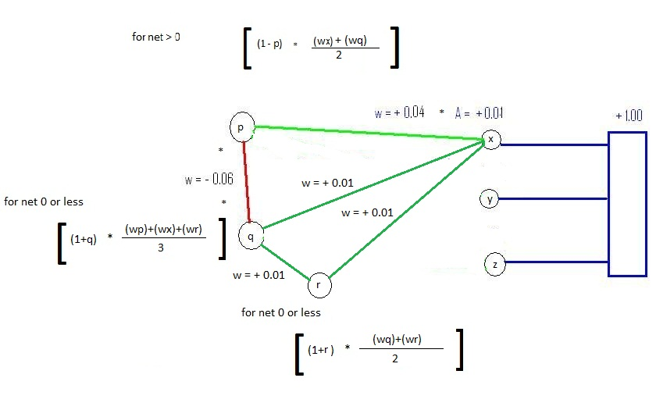
Figure 1: Simplicity

Explanatory Breath shows a competition between two contradictory hypotheses. The network accepts the hypothesis that accounts for more observational data.

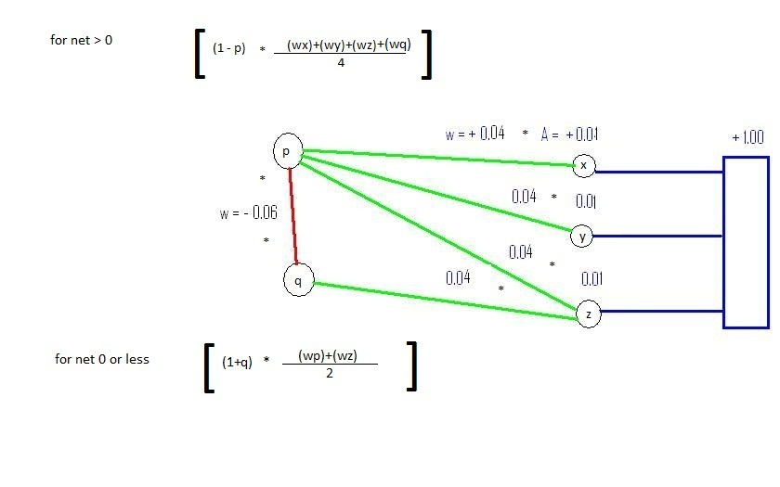
Figure 2: Explanatory Breath

Here since there are more observations linking hypothesis one, the network accepts hypothesis one and rejects its competitor. In the actual programed examples acceptance is visualized (interpreted according to) by increase in size of the circles. Larger circles indicate high levels of activation. If a node reaches a critically low value, it changes from a circle to a triangle indicating rejection. As a neurological analog this reflects the now well accepted notion that neurons that wire together fire together.

Theory, Meta-Theory and Background Belief

Scientific theory does not exist in a vacuum. None of our beliefs do. Each and every of our concepts is intertwined with an assortment of background beliefs that shape and constrain how we are able to theorize about the buzzing and blooming confusion that is provided by our senses. Thus, network development should provide a means for dynamic representation of the impact of an assortment of background beliefs that might be called upon in the assessment of any nexus of lower level hypotheses. My models provide this capability using no other complexity than is introduced through the principles of simplicity and explanatory breath.

Taxa, Language learning and Action (dthat)

Providing a network with the preceding capabilities will be enough to demonstrate rational judgment in the consideration of competing theories. For our purposes, however, it will not be enough to provide the networks with prebuilt theories and concepts. We are concerned, also, with concept acquisition and attitudes towards such concepts. To this end I’ve created a sub-network that traces the acquisition of concepts via neural connections that map onto bodily acts and behavioral performances. These neural bundles can be expected to trace the learning of the referent of theory terms through experimental procedures and local practice standards. The neurological basis for this model corresponds to a complex set of neurological structures.

Emotion, Methodological Values and Action

So far it has been merely a matter of adding and appropriately connecting neuron bundles according to the constraints of simplicity and explanatory breath. This was even the case in building the connections required to account for concept acquisition and learning contexts. But, if we want to provide a basis for understanding failures of rationality and the problems for naturalism raised by different versions of incommensurability, it is will prove useful to model the role of affect in forming and maintaining methodological values and concordant action. The Demassios’ somatic marker hypothesis provides another tile for our mosaic. According to Bechara, Hanna Damasio and Antonio R. Damasio, (2000)

The somatic marker hypothesis is based on the following main assumptions: (i) that human reasoning and decision making depend on many levels of neural operation, some of which are conscious and overtly cognitive, some of which are not; conscious, overtly cognitive operations depend on sensory images based on the activity of early sensory cortices; (ii) that cognitive operations, regardless of their content, depend on support processes such as attention, working memory and emotion; (iii) that reasoning and decision making depend on the availability of knowledge about situations, actors, options for action and outcomes; such knowledge is stored in ‘dispositional’ form throughout higher-order cortices and some subcortical nuclei (the term dispositional is synonymous with implicit and non-topographically organized) [details on dispositional knowledge and the convergence zone framework are presented elsewhere (Damasio, 1989a,b, 1994; Damasio and Damasio, 1994)]; dispositional knowledge can be made explicit in the form of (a) motor responses of varied types and complexity (some combinations of which are part of emotions) and (b) images. The results of motor responses, including those that are not generated consciously, can be represented in images; and (iv) that knowledge can be classified as follows: (a) innate and acquired knowledge concerning bioregulatory processes and body states and actions, including those which are made explicit as emotions; (b) knowledge about entities, facts (e.g. relations, rules), actions and action-complexes (stories), which are usually made explicit as images; (c) knowledge about the linkages between (b) and (a) items, as reflected in individual experience; and (d) knowledge resulting from the categorizations of items in (a), (b) and (c) (295-307).
I can begin to encompass some of the Somatic Marker hypothesis in my models by creating a new source of activation flowing to nodes representing goals and desires. This source of activation will find its analog in the body, in glands and hormones responsible for the production of affect. Ultimately goals and desires that lay behind the bodily actions that constitute scientific methods are produced through care.

Harry’s Brain
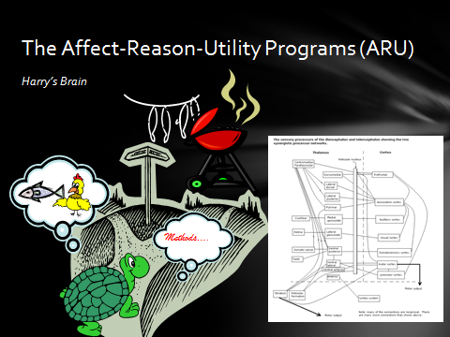

I am developing the model of Mary’s epistemic states by superimposing the specific constraints of Mary’s history onto a more general and more basic model – Harry. I was inspired to create this model by watching my pet turtle. Harry likes food. He’s disposed to go after whatever he can recognize as food. In his environment he is provided with two types of food – chicken and fish. He’s able to perform his food getting behaviors by tapping into his prior experiences that went into forming concepts for each class of food. He has access, we might say, into two simple reptilian theories of food either, or both, of which may truly coincide with future facts. But, he learned different successful food getting behaviors for each of his foods, different methodological norms – crawls toward chicken, swims after fish. Indeed, he learned each object through a different neural pathway - perhaps he smells fish and sees chicken. So, the bodily actions required for each food must have its own cognitive structure as well. And, each of these must cohere with the desired object and be capable, via negative constraints, of suppressing methods that will be unsuccessful.
We have in this model all that is required to model the potential for both semantic and methodological incommensurability between competing scientific theories. Below is a chart of the neural correlates required to capture Harry and Mary’s predicament. We have but to replace (chicken and fish) with (monochrome, polychrome) while (swim, crawl) is replaced by relevant cones & rods of the eye.
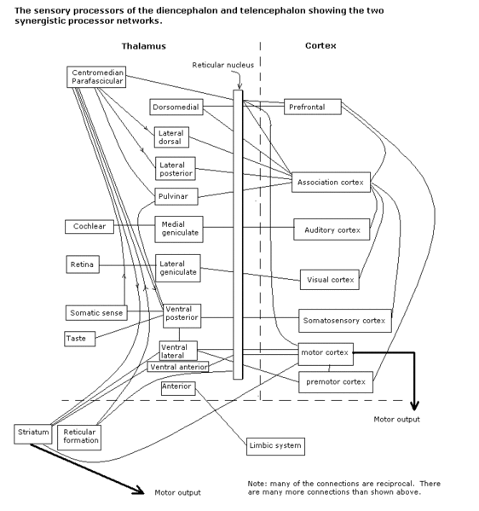

Conclusions further thoughts

I think our mosaic shows that here is no in principle bar to a connectionist interpretation of the Knowledge Argument. I believe that consideration of the incommensurability thesis provides useful schemata for framing the argument.
A plausible PDP explanation of belief justification in terms of coherence and information raises new challenges for defenders (and critics) of the knowledge argument that could not have been discovered otherwise. Specifically, holistic and competitive information acceptance is better suited for grounding the knowledge argument because, it comports with current mathematical and neurophysiological theory, solves the ‘counting knowledge’ problem, provides a means for dealing with the threat of incommensurability, and suggests the possibility of un-mined alternative outcomes, e.g., the possibility of less knowledge. Other plausible predictions include a type of blind sight or acquired colorblindness.

Do traditional approaches to the knowledge argument compete with the offered PDP approach?
Is reduction of one to the other a desirable goal? Why or why not.
Some practical outcomes
Possible teaching tools
Possible mental health treatments.

References

Antoine Bechara, Hanna Damasio and Antonio R. Damasio, (2000) Emotion, Decision Making and the Orbitofrontal Cortex, Cereb. Cortex 10 (3): 295-307. doi: 10.1093/cercor/10.3.295
Chalmers, D., 1990, “Syntactic Transformations on Distributed Representations,” Connection Science, 2: 53–62.
Churchland, P.M., 1995, The Engine of Reason, the Seat of the Soul : a Philosophical Journey into the Brain, Cambridge, Mass.: MIT Press.
Conee 1985
Dennett, Dan 2006 "What RoboMary Knows", in Alter, Torin, Phenomenal Concepts and Phenomenal Knowledge, Oxford Oxfordshire: Oxford University Press
Feyerabend (1962)
Hinton, G. (ed.), 1991, Connectionist Symbol Processing, Cambridge, Mass.: MIT Press.
Jackson, Frank 1982 Epiphenomenal Qualia Philosophical Quarterly, 32, pp. 127-36.
Jackson, Frank 2011 Philosophy Bites podcast, Frank Jackson on What Mary Knew, url:http://philosophybites.com/2011/08/frank-jackson-on-what-mary-knew.html
Kuhn, Thomas (1962) The Structure of Scientific Revolutions
Kuhn, Thomas (1970) The Road Since Structure
Lewis, David 1983 Postscript to “Mad Pain and Martian Pain”, in D. Lewis, Philosophical Papers (Volume 1), Oxford: Oxford University Press.
Loar 1990
Nemirow, Laurence 2004 in Ludlow, Peter; Nagasawa, Yujin; Stoljar, Daniel, eds. (2004). There's Something about Mary: essays on phenomenal consciousness and Frank Jackson's knowledge argument. Cambridge: MIT Press.
Pappinaue, David Sept 2007 http://plato.stanford.edu/entries/naturalism/
Rumelhart, D.E., J.L. McClelland and the PDP Research Group (1986). Parallel Distributed Processing: Explorations in the Microstructure of Cognition. Volume 1: Foundations, Cambridge, MA: MIT Press
Sankey, Howard (1994)
Shannon 1948 , “A Mathematical Theory of Communication,” Bell System Technical Journal, 27: 379–423, 623–656
Smolensky, P., 1991, “Tensor Product Variable Binding and the Representation of Symbolic Structures in Connectionist Systems,” in Hinton (1991), 159–216.
Thagard, Paul 1992. Conceptual revolutions. Princeton, NJ: Princeton University Press,
Thagard, Paul 2000. Coherence in thought and action. Cambridge, MA: MIT Press.

Mary could well have stated the same sort of assertions about color before leaving the room. But those assertions could only have been in bad faith or else grounded in some non-colorfulfilled learning experience.
Jackson denies that this amounts to causal responsibility. His view at that time was that qualia are epiphenomenal properties having no causal effects on the physical. He has since abandoned epiphenomenalism.
. Jackson now hold a representational realist view that aspects of experience are represented by various modalities and retrieval features of brains and color presentation and representation are merely one of such modalities. The ‘feelie’ aspect of color is something like motion on a film sequence of slides (cf. Jackson 2011)
. David Chalmers and Paul Churchland, for example, revise the argument to clarify an ambiguity while Loar and Horgan revise the logical structure of the argument to make semantic points.
Moreover, the ‘Mary’ thought experiment is inoculated against weaker supervenience based brands of Physicalism that withhold an ‘and that’s all’ clause.
Acceptance of casual closure of the physical realm implies strong naturalism. Any mental and biological causes must themselves be physically constituted, if they are to produce physical effects. This gives rise to a particularly strong form of ontological naturalism, namely Physicalism. But, weaker brands of naturalism are possible, e.g. vitalism which does not appreciate causal closure. The term ‘naturalized epistemology’ covers a number of different ideas, some of which relate to methodological issues rather than ontological ones . . . . (Feldman 2006.) If our approach is coherence based and is governed my methodological constraints, ways of arriving at beliefs are to be assessed in terms of their consequences, including most centrally their reliability at producing true beliefs. These consequentialist assessments will give rise to evaluations of ways of arriving at beliefs, but these evaluations will be derivative and not [dependent] on any independent norms governing the formation of beliefs (Pappinaue 2007).
“The brain amounts to a vector processor and the problem of psychology is transformed into questions about which operations on vectors account for the different aspects of human cognition.” According to Churchland (1995)
Shannon information: the entropy, H, of a discrete random variable X is a measure of the amount of uncertainty associated with the value of X (Shannon 1948).
See Thagard 1992
Kuhn puts it this way, “To the extent that I'm concerned with language and with meanings at all . . . it is with the meanings of a restricted class of terms. Roughly speaking, they are taxonomic terms, a widespread category that includes natural kinds, artificial kinds, social kinds, and probably others. . . . If different speech communities have taxonomies that differ in some local area, then members of one of them can (and occasionally will) make statements that, though fully meaningful within that speech community, cannot in principle be articulated by members of the other (1991 p. 315).
Not only at the level of comparison between semantic theory of critical review.
The pragmatic instrumental naturalist would like to be able to point to comparative strategies like Laudan’s R1 to answer the threatened meta-methodological incommensurability but that project has its critics. Multi-domain incommensurability is a kind of incommensurability that is threatened when the terms and concepts used to solve semantic and methodological incommensurability are conflated at the meta-methodological level. I have shown elsewhere that this possibility constitutes a high level threat to Popperian philosophy of science that relies upon a demarcation between science and non-science.
Principle E1. Symmetry. Explanatory coherence is a symmetric relation, unlike, say, conditional probability. That is, two propositions p and q cohere with each other equally. Principle E2. Explanation. (a) A hypothesis coheres with what it explains, which can either be evidence or another hypothesis; (b) hypothesis that together explain some other proposition cohere with each other' and (c) the more hypotheses it takes to explain something, the lower the degree of coherence.Principle E2. Analogy. Similar hypotheses that explain similar pieces of evidence cohere.Principle E4. Data priority. Propositions that describe the results of observations have a degree of acceptability on their own.Principle E5. Contradiction. Contradictory propositions are incoherent with each other.Principle E6. Competition. If P and Q both explain a proposition, and if P and Q are not explanatorily connected, then P and Q are incoherent with each other. (P and Q are explanatorily connected if one explains the other or if together they explain something.)Principle E7. Acceptance. The acceptability of a proposition in a system of propositions depends on its coherence with them.
This much has been shown by my ARU models and by ECHO, Thagards equivalent program group.
This set of neural connections is suggestive of David Kaplan’s dthat semantic theory.
Because of time and space considerations I’ve left out many relevant details here. Please examine the ARU program itself for the particulars.

